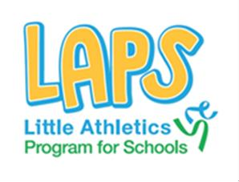

LAPS is an outstanding educational athletics program that provides a fun and educational experience to each student, working through the fundamental
movement skills of running, jumping and throwing. A couple of things for schools to remember:
- Each school involved must run a Little Athletics ACT promotional flyer in their school newsletter.
- Group sizes cannot exceed 30 students.
- One teacher must accompany each group.
- Each session is 30 minutes in duration.
- LAPS sessions booked before 1 September must have access to an inside area in case of inclement weather.

How do I make a booking?

Please complete the form below and email to participation@capitalathletics.au

BOOKING ENQUIRY FORM

SCHOOL CONTACT INFORMATION
School:
Address:
Phone: Email:

Contact person: Contact no:
Please note that in the case of large class numbers, two or more days may be required

Please complete the table below for each class that is participating

Class name | Year Level | No. of students |  | Class name | Year level | No. of students

Do you have an undercover area where sessions can continue in the case of wet weather? No
Yes
Do you have a safe and well-maintained long jump pit? No
Yes
What size newsletter ad would you like Little Athletics ACT to create for your publication?

SCHOOL TIME SCHEDULE

School commencement time: Recess commencement: Recess conclusion: Lunch commencement: Lunch concludes: School day concludes:

